Data collection

1. SOFA

Anatomy of sofa:

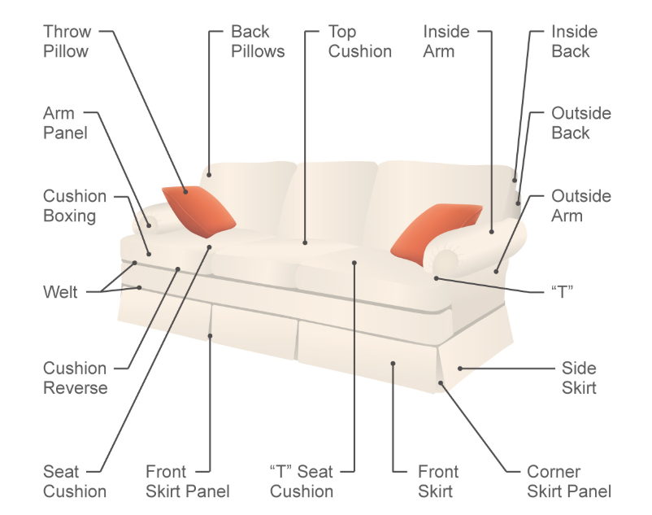

SOFA TYPES

* SECTIONAL SOFA:

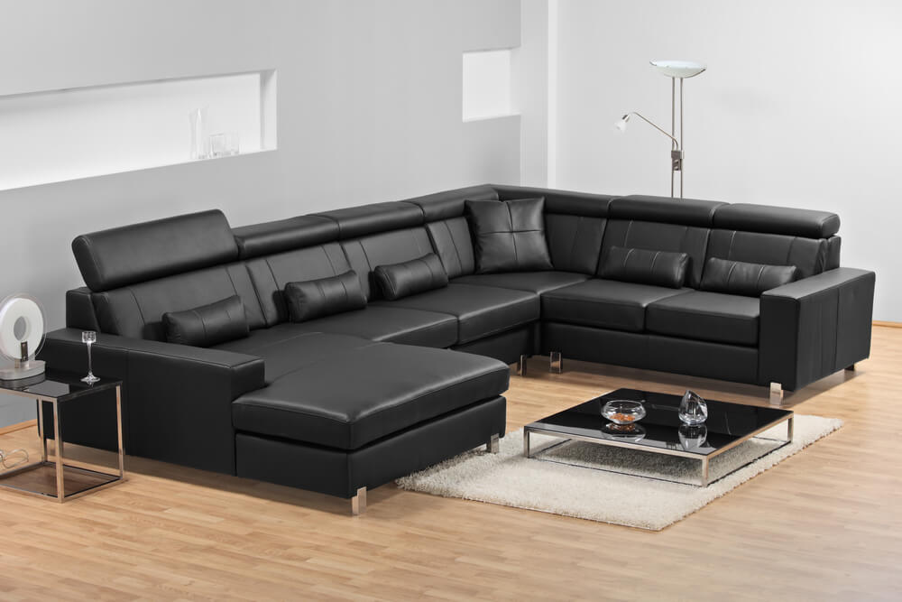

LINK: <https://www.homestratosphere.com/types-of-sofas/#foobox-2/0/Black-Leather-Sectional-Sofa.jpg>

**2. Chesterfield**

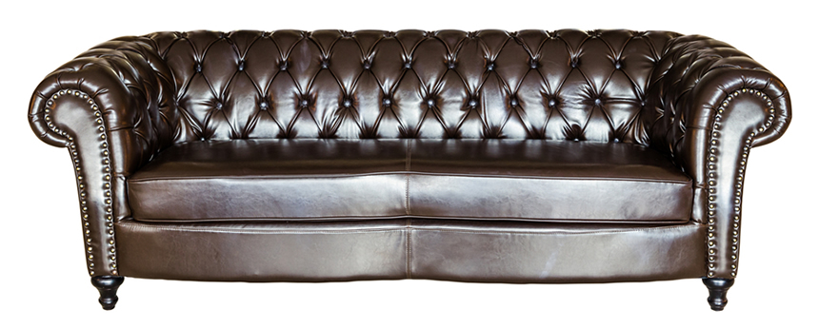

<https://www.homestratosphere.com/types-of-sofas/#foobox-3/0/Leather-Chesterfield-Sofa.jpg>

**3. Lawson-style Sofa**

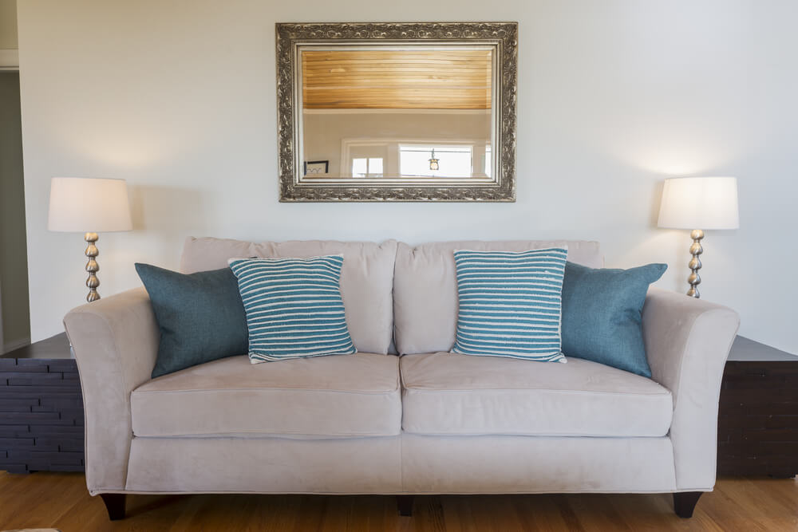

<https://www.homestratosphere.com/types-of-sofas/#foobox-4/0/Lawson-style-sofa.jpg>

**4. Mid-century Modern**

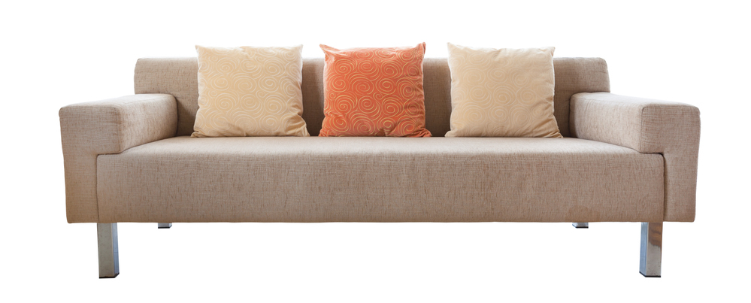

<https://www.homestratosphere.com/types-of-sofas/#foobox-5/0/Midcentury-modern-sofa-design.jpg>

**5. Contemporary Mid-century Modern Sofa**

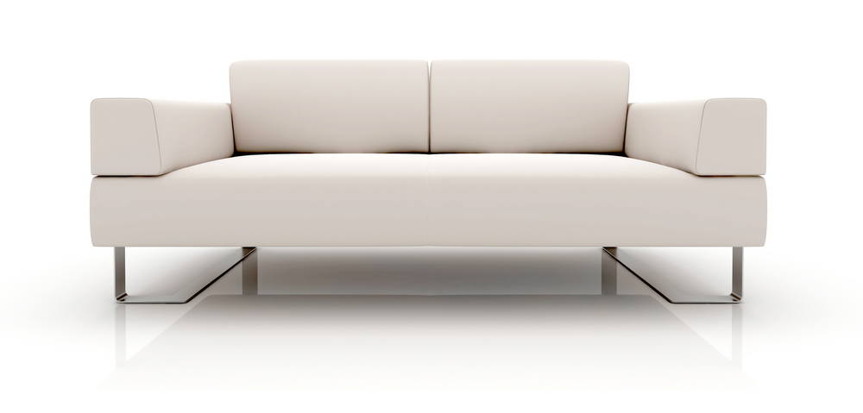

<https://www.homestratosphere.com/types-of-sofas/#foobox-6/0/Modern-sofa-design.jpg>

**6. Bridgewater:**

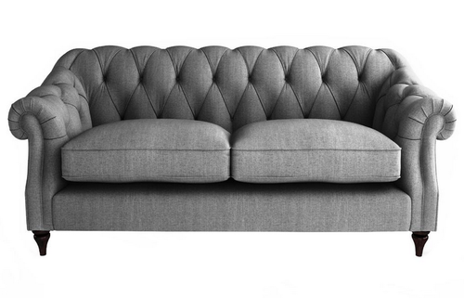

<https://www.google.co.in/search?q=bridgewater+sofa&safe=active&source=lnms&tbm=isch&sa=X&ved=0ahUKEwjz6bnRyo7dAhWIK48KHZatB1oQ_AUICigB&biw=1280&bih=635#imgrc=xzSNTbWfySM3xM>:

**7. English Rolled Arm Sofa**

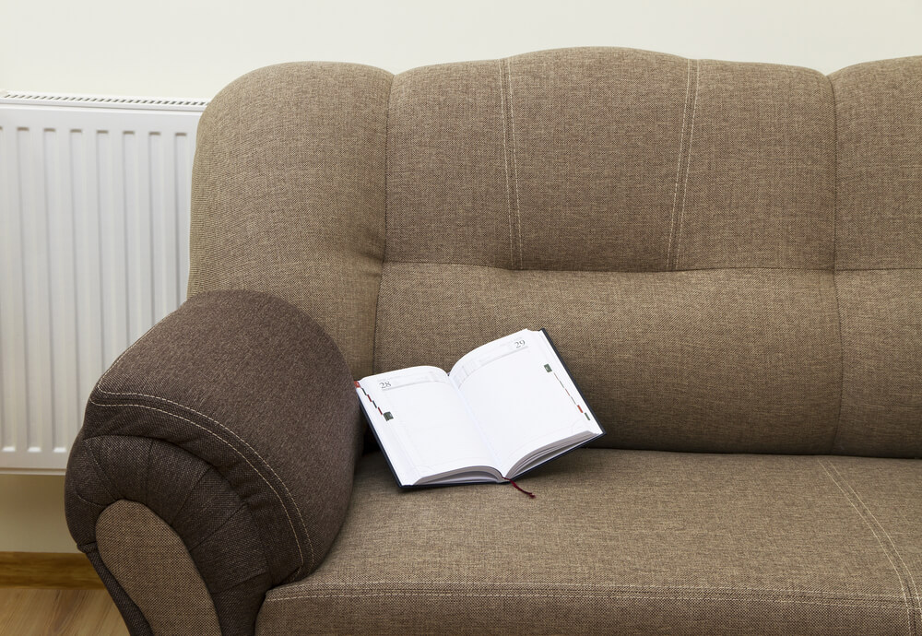

<https://www.homestratosphere.com/types-of-sofas/#foobox-7/0/Bridgewater-Sofa-Design.jpg>

**8. Camel back**

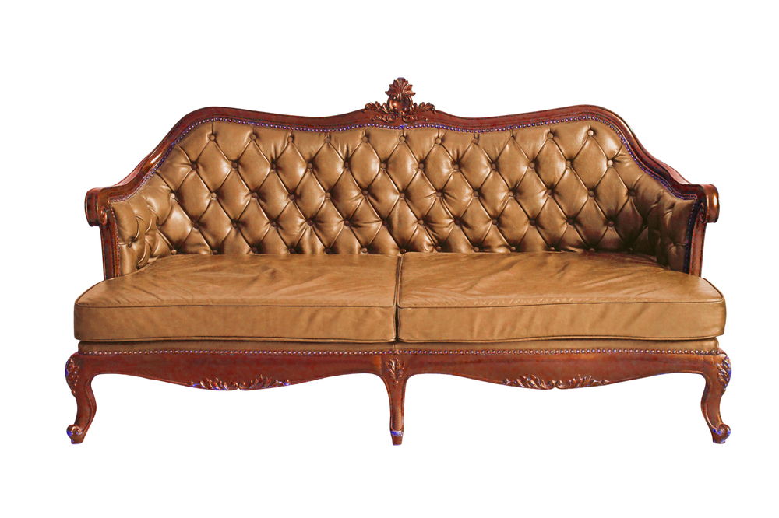

<https://www.homestratosphere.com/types-of-sofas/#foobox-9/0/Camelback-sofa.jpg>

**9. Cabriole**

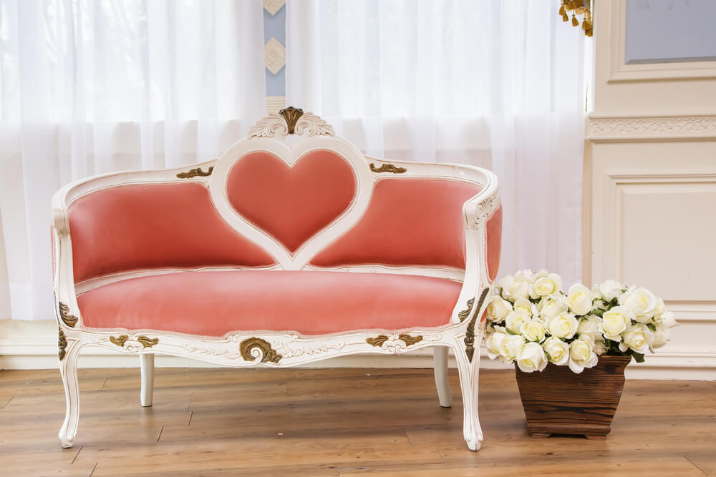

<https://www.homestratosphere.com/types-of-sofas/#foobox-10/0/Cabriole-Sofa.jpg>

**10. Chaise Lounge**

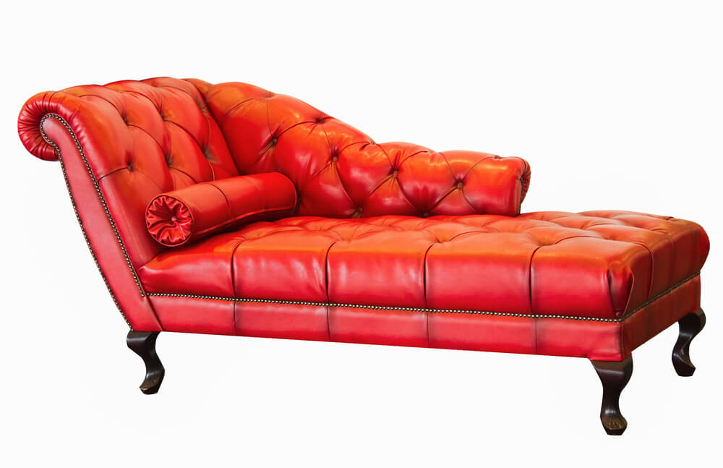

[**https://www.homestratosphere.com/types-of-sofas/#foobox-11/0/Red-leather-chaise-lounge.jpg**](https://www.homestratosphere.com/types-of-sofas/#foobox-11/0/Red-leather-chaise-lounge.jpg)

**11. Divan**

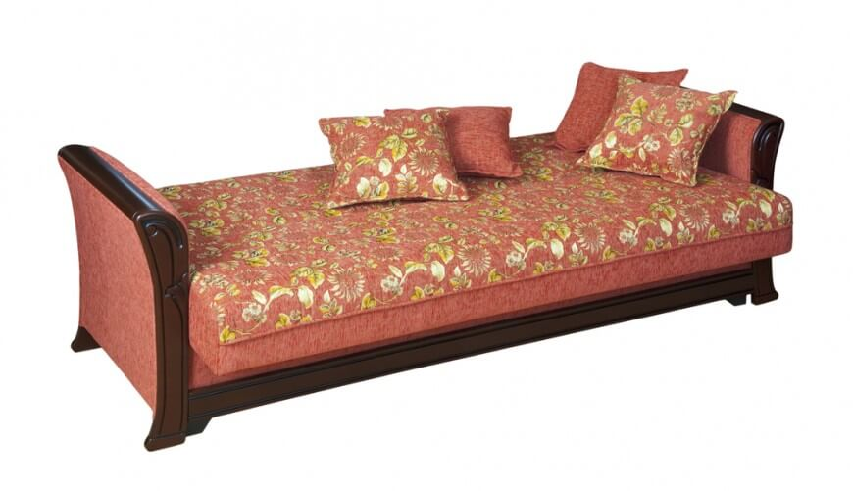

[**https://www.homestratosphere.com/types-of-sofas/#foobox-18/0/example-of-divan-nov29.jpg**](https://www.homestratosphere.com/types-of-sofas/#foobox-18/0/example-of-divan-nov29.jpg)

**12. Settee Sofa**

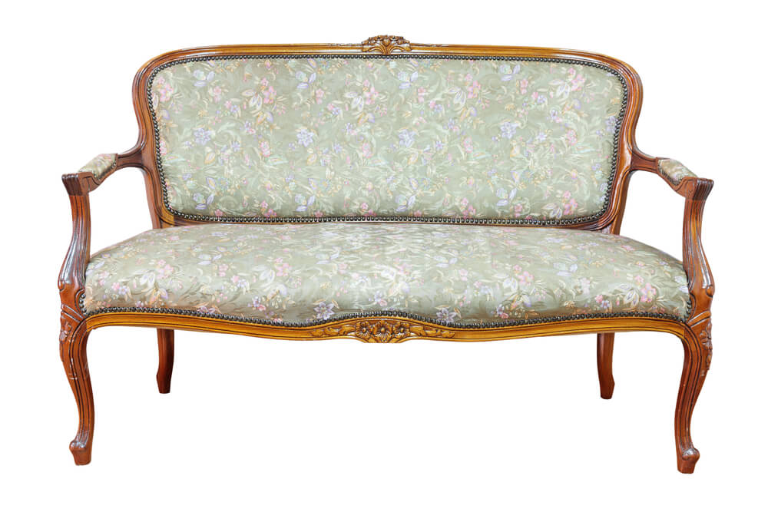

[**https://www.homestratosphere.com/types-of-sofas/#foobox-19/0/Settee.jpg**](https://www.homestratosphere.com/types-of-sofas/#foobox-19/0/Settee.jpg)

**13. Tuxedo Sofa**

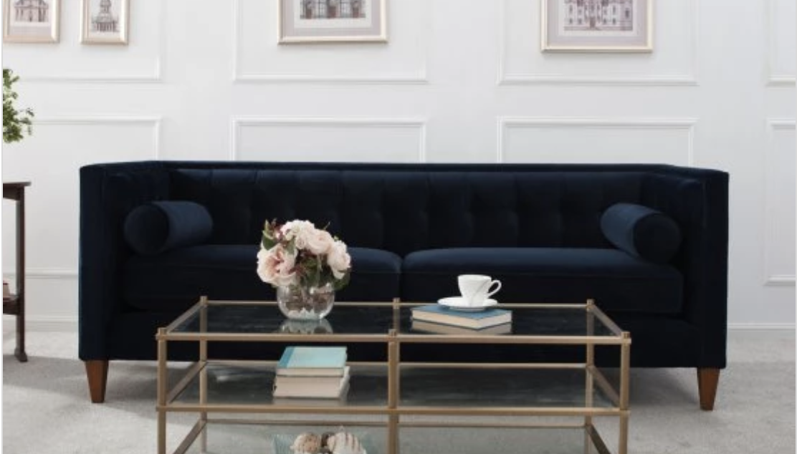

[**https://www.homestratosphere.com/types-of-sofas/#foobox-21/0/hay-photo-tuxedo-sofa-nov29.png**](https://www.homestratosphere.com/types-of-sofas/#foobox-21/0/hay-photo-tuxedo-sofa-nov29.png)